Login to your router at http://192.168.1.1
Default Router Username: root
Default Router Password: admin
You will need to hook up the Cat5 from your pc or laptop to access the router correctly.
Step 1) Setting up your DNS Settings.
(Make sure they look like below) And scroll to the bottom and press Apply)
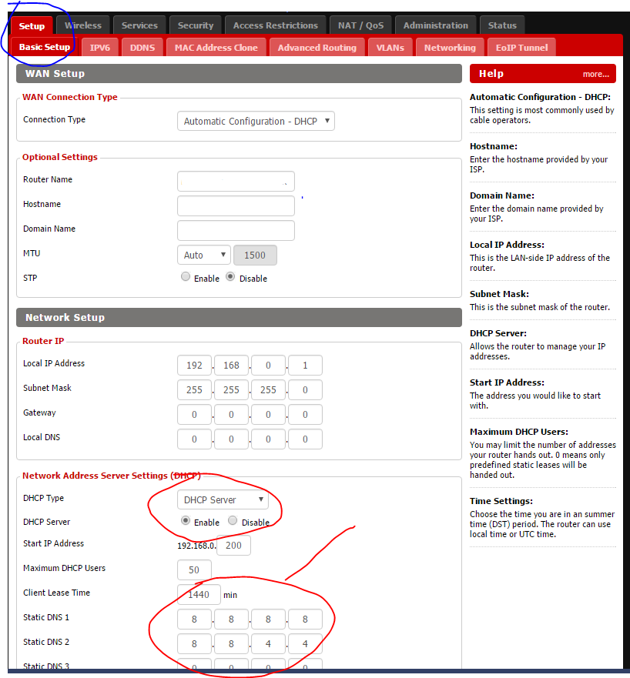
Step 2) Go to the Wireless Tab and then Basic Settings Tab
Change the 2.4 Ghz Radio SSID to something like “MyRouter2.4” or “DDWRT2.4”
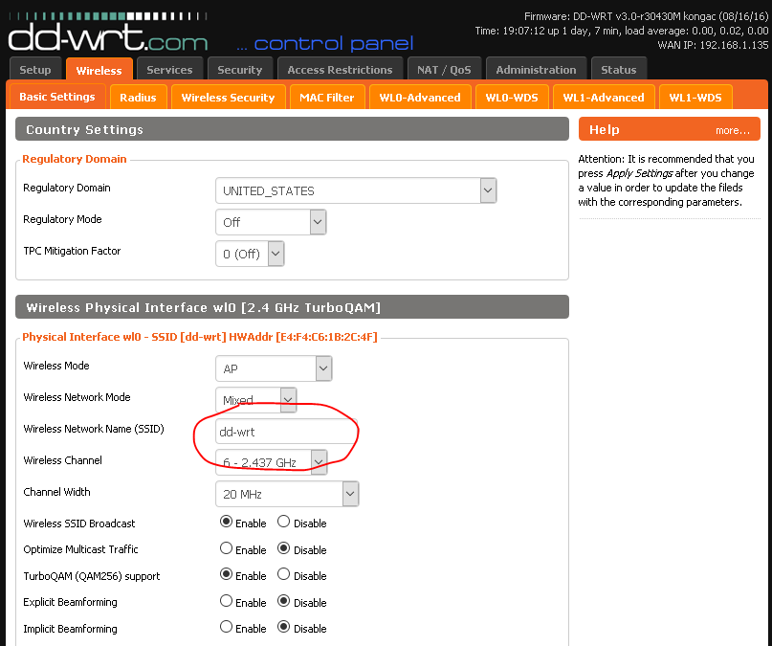

Step 3) Now we do the same for the 5ghz (Fastest Wifi Radio)
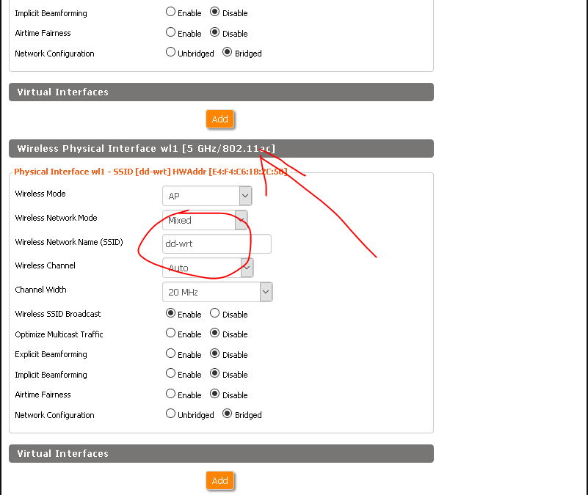

Scroll to the bottom and press Apply. You should now see you Wifi Radio’s changed on the laptops and devices you are connecting with will see your new wifi name. When you search for the Nearest wifi signals.

Step 4) Now you need to secure your Wifi Security
Select your Wireless Tab and then the Wireless Security Tab
Setup your SSID Shared Keys to something you will remember atleast 8 Characters (We suggest 12 with special characters) After you have your settings looking like this press apply.

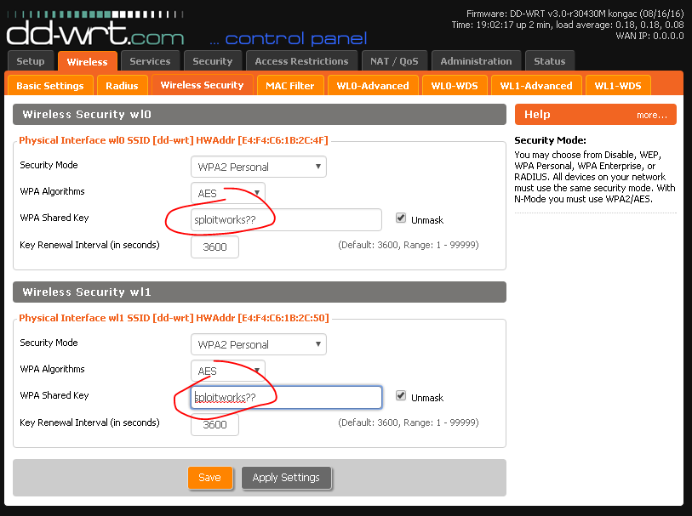

Step 5) Securing Your Router Access
Last but not least you need to secure your router Username and Password to Access the Router.
Enter what you want CAREFULLY into the boxes below. If you mess the username up you will not be able to login and need to reset your router and start all over. Write your settings down.
After you have your settings as below scroll to the bottom and press apply. That’s it!

