Router Security Notes.
The default username and password is on the bottom of the router. ALWAYS login to the interface and Change this username and password to secure your router (Administration.…Management) . Do not give this information to anyone. The WPS button is disabled by default for security reasons in DDWRT. You can enable it within DDWRT if you need it.
Stability
Stability. This Netgear comes with DD WRT which is in our opinion the most stable DD WRT firmware for this model of router right now. However, stability on routers is our primary goal so….
Always Enable “Keep Alive Settings” so that your DD WRT Router is stable. Go to “Administration” then “Keep Alive” then enter the settings below. We Always Reboot the Router every day to clear out any and all Garbage that may accumulate. Rebooting takes but a few minutes.
We suggest the following settings…
- Schedule Reboot (Every Morning at 3:30AM) – or… Whatever time you know you will not be active.
- Use Google DNS server of 8.8.8.8 (Server should never be down) for CONNECTION WATCHDOG.
This insures that your router will always keep itself up and running and you should never have to reset it because of Network Crashes or any other reason. Please take our advice. DD WRT is an ongoing BETA project and this will make you very happy if you follow our recommendations. In our experience with routers Connection keep alive is mandatory.

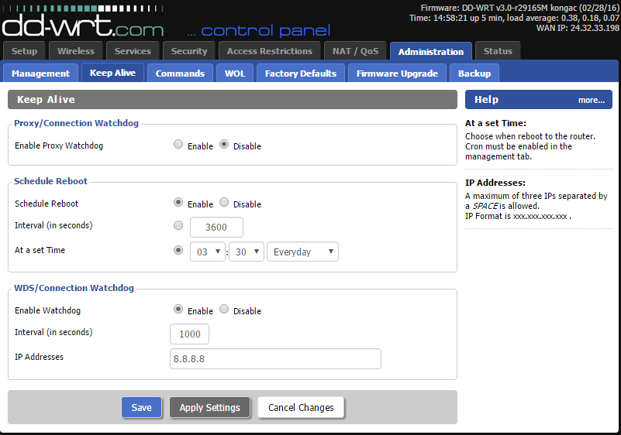

For Questions email: sales@sploitworks.com
Thank you.
Upgrading DD WRT
We may from time to time have upgrade recommendations in case you are experiencing any stability issues.
If you email us, we will send you the firmware upgrades.
This is how you install them.
- Open the web interface at http://192.168.1.1 and go to Administration… Firmware Upgrade. Then browse for the file we sent you. Open it… Then press “Upgrade”. WAIT A FULL 5 MINUTES. DO NOT UNLUG THE ROUTER OR TOUCH IT.
- Enjoy

How to reset to DD WRT Defaults
(Warning this will erase your settings INCLUDING VPN CONNECTIONS on the router.)
- Get a paper clip.
- With the Router Powered on, insert the paperclip into the factory reset port until you see the Light Flash Amber and then release. Wait 3 minutes. Then login to http://192.168.1.1
- Use the default username and pass for DD WRT on the router.

